GRADE 7- THE second- FINAL SEMESTER REVISION
I. Choose the correct word, phrase or utterance (A, B, C or D) to fill in the blank space. (1.5 pts)
1. Choose the word that has the underlined part pronounced differently from that of the others.
A. this B. although C. weather D. health
2. For our__________________, we grew sunflowers in our classroom.
A. homework B. science project C. book report D. history essay
3. Canadians enjoy tea as part of their daily routine. That’s ______the British.
A. the same B. like C. different D. likely
4. We took a tour of _________ Eiffel Tower and _________ Louvre Museum.
A. -/the B. an/the C. an/- D. the/ the
5. The ceremony occurs ______the mid-autumn season in the ancient town of Hoi An to celebrate the full moon.
A. on B. at C. from D. in
6. A: "How about we try out that new coffee shop downtown? It could be fun!" - B: "__________________"
A. That sounds great! C. Take care and see you next time!
B. No. Don’t be silly! D. Let’s do this again sometime soon.
II. What do the following signs mean? Choose the most correct answer (A, B, C or D). (0.5 pt)
7.  A.  B.  C.  D. | What does the sign mean?  Students queue up.  Passengers line up.  Shoppers wait patiently for their turn.  Customers aren’t waiting for assistance. |  | 8.  A.  B.  C.  D. | What does the sign mean?  Renewable energy.  Non- renewable energy.  Clean and safe energy.  Eco-friendly energy sources. | 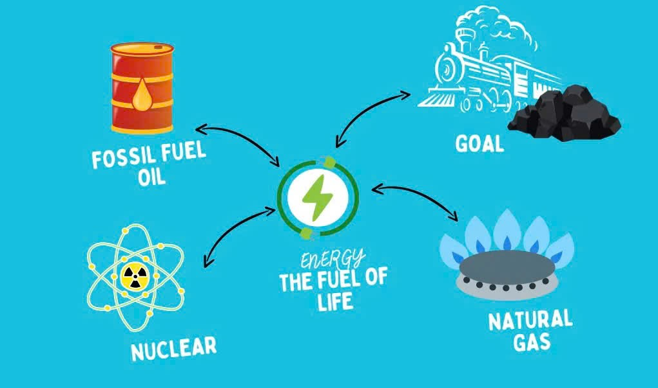

III. Supply the correct form of the word in each bracket below. (1.0 pt)
9.________________, the rain stopped just in time for the outdoor concert. ( Luck)

10. The river near the factory has become heavily ___________due to waste being dumped into it. (pollution)
11. The city skyline is filled with tall _______________ that house offices, apartments, and shops. ( build)

12. Many European countries share the tradition of ________ a big family meal on Christmas Day. ( have)
IV. Supply the correct form of the verb in each bracket below. (2.0 pt)
13. She _______________ eating spicy food. ( not/ like)
14. They _________________ their anniversary with a grand party next week." (celebrate)
15. They ____________ the English speaking contest tomorrow. ( not/attend)
16. Yesterday, my mom ____________ me a beautiful dress as a gift for my birthday. ( give)
V. Read the passage then answer the questions. (1.0 pt)
Hi Lan, I’m having such a great time here in Sydney. I’ve been practicing my English every day, and I can feel myself improving. Last week, I visited the Sydney Opera House. I took the ferry to get there, which was an adventure in itself! At first, I was a little bit shy about speaking English, but now I’m enjoying using it to talk to locals and explore new places. On Sunday, I went to a cricket match. Australians are so crazy about cricket. I met a guy named Jake, who kindly explained the rules of the game to me. It made the experience so much more enjoyable! He even gave me his phone number, so we can stay in touch. I’m coming back to Vietnam next week, but I really wish I could stay longer to practice my English even more.
Take care, Minh
17. Did Minh visit the Sydney Opera House during the trip?
____________________________________________________
18. How did Minh travel to the Sydney Opera House?
____________________________________________________
19. What sport did Minh watch on Sunday?
____________________________________________________
20. Who explained the rules of cricket to Minh?
____________________________________________________
VI. A. Read the following passage and write True or False. (1.0 pt)
Hung Kings’ Anniversary is celebrated on the 10th day of the third lunar month and it’s one of the most important traditional events. The event takes place at the Hung Kings’ Temple in Phu Tho Province, attracting visitors from across the country. People have a chance to remember the Hung Kings who are the first kings of the nation.
During the festival, people wear colorful, traditional clothes and pray at the temples. They enjoy cultural performances, such as traditional folk songs and dances. People also participate in activities like cooking contests, traditional games like tug-of-war and bamboo dancing. Hung Kings’ Anniversary is a meaningful occasion for national pride and unity among the Vietnamese people.
21. Hung Kings’ anniversary is celebrated on the 10th day of the third lunar month. _________
22. The festival takes place in Hanoi every year. _________
23. People participate in traditional games like tug-of-war and bamboo dancing during the festival. _________
24. The celebration is a meaningful occasion for national pride and unity among the Vietnamese people. _________
VII.A. Rewrite the following sentences without changing the meaning.(1.5 pts)
25. The design of this new tower is not the same as the old one.
The design of the old building is _____________________________________________________________
26. These candies have more sugar than fruit juice.
Fruit juice ______________________________________________________________________________
27. It’s necessary for us to conserve water to protect the environment.
We have ________________________________________________________________________________
- Arrange these words into their correct orders. (1.5 pts)
28. / for its ancient culture./ a historic / Hoi An is / town in / Vietnam known /
__________________________________________________________________________________
29. /be cooking / air ballon shows. / music and hot / There will/ competitions, live/
__________________________________________________________________________________
30. / I believe that / the next generations. / will help create a cleaner/ solar power / and greener planet for /
________________________________________________________________________________
The end

